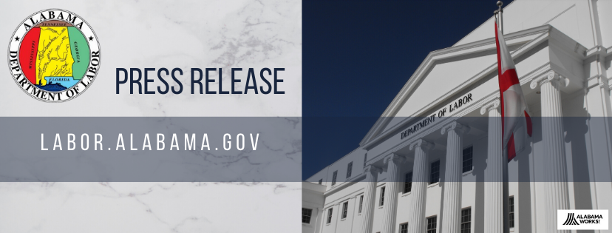

News Release
For Immediate Release: March 24, 2023

Alabama’s Unemployment Rate Drops to 2.5%, Ties Record Low
Jobs Grew by Nearly 44,000 Over the Year

MONTGOMERY – Governor Kay Ivey announced today that Alabama’s preliminary, seasonally adjusted February unemployment rate is 2.5%, tying the all-time record low, down from January 2023’s rate of 2.6%, and below February 2022’s rate of 2.6%. February 2023’s rate represents 56,221 unemployed persons, a new record low, compared to 58,392 in January 2023 and 58,943 in February of 2022.
“Once again, we’ve hit a record low unemployment rate,” said Governor Ivey. “While it may seem we break these records month after month, we know that even with record low unemployment we still have a duty to provide good, quality jobs to every Alabamian who wants one. I’m proud of our economic successes and reaffirm my commitment to continue to the work to make this state the best it can be.”
Wage and salary employment, totaling 2,133,500 in February, increased 15,900 over the month. Monthly gains were seen in the professional and business services sector (+3,800), the government sector (+3,500), the leisure and hospitality sector (+3,400), the private education and health services sector (+3,200), the manufacturing sector (+1,100), the construction sector (+700), and the information sector (+300), among others.
Wage and salary employment increased 43,900 over the year, with annual gains seen in the private education and health services sector (+8,600), the manufacturing sector (+8,200), the government sector (+7,600), the professional and business services sector (+7,300), the leisure and hospitality sector (+4,900), the other services sector (+3,600), the construction sector (+3,400), the information sector (+900), and the financial activities sector (+800), with the other services sector setting an all-time record high jobs count.

“Job growth of nearly 44,000 over the year is definitely something to be proud of,” said Alabama Department of Labor Secretary Fitzgerald Washington. “We know that employers still have jobs that need to be filled, and we’re working to match those employers with those jobseekers. Our Career Center System has so many tools to help everyone succeed – I would definitely recommend visiting your local center if you need any assistance.”
Counties with the lowest unemployment rates are: Shelby County at 1.7%, Morgan County and Madison County at 1.9%, and St. Clair County, Marshall County, Limestone County, Elmore County, Cullman County, and Blount County at 2.0%. Counties with the highest unemployment rates are: Wilcox County at 8.0%, Greene County at 5.5%, and Dallas County at 5.1%.
Major cities with the lowest unemployment rates are: Homewood and Madison at 1.5%, Trussville and Vestavia Hills at 1.6%, and Alabaster, Hoover, and Northport at 1.7 %. Major cities with the highest unemployment rates are: Selma at 6.5%, Prichard at 4.3%, and Bessemer at 3.8%.

###

Members of the media seeking more information should contact Communications Director Tara Hutchison.

An Equal Opportunity Employer / Program
Auxiliary aids and services available upon request to individuals with disabilities.
Dial 711 for TTY Accessibility

“Seasonal adjustment” refers to BLS’s practice of anticipating certain trends in the labor force, such as hiring during the holidays or the surge in the labor force when students graduate in the spring, and removing their effects to the civilian labor force.
The Current Population (CPS), or the household survey, is conducted by the Census Bureau and identifies members of the work force and measures how many people are working or looking for work.
The establishment survey, which is conducted by the Bureau of Labor Statistics (BLS), a division of the U.S. Department of Labor, surveys employers to measure how many jobs are in the economy. This is also referred to as wage and salary employment.

