Proclamation

By the Governor of Alabama

WHEREAS, reinforced concrete pipe and precast concrete products are of vital importance to sustainable communities and to the health, safety, and well-being of the people of Alabama; and

WHEREAS, reinforced concrete pipe and precast concrete products and services could not be provided without the dedicated efforts of the concrete pipe and precast concrete industry, the trucking industry, the sand and rock producers and the cement producers and employees. Responsibilities include designing, manufacturing, distributing, educating and supplying reinforced concrete pipe and precast concrete products to the owners and contractors. Additional responsibilities include designing, constructing and maintaining all developments. This includes transportation and storm drainage infrastructure and residential and commercial subdivisions. All which are essential to our citizens; and

WHEREAS, it is of public interest for the citizens, civic leaders and children in Alabama to gain knowledge of and to maintain a progressive interest and understand the importance of reinforced concrete pipe and precast concrete in their respective communities, that it is made of all natural materials rock, sand, water and cement, which Alabama supplies; and

WHEREAS, the year 2022 marks the 115th year of the American Concrete Pipe Association, which began as a means of exchanging ideas and establishing a high quality, standardized product, which the Concrete Pipe Producers in Alabama fully supports in both actions and deeds;

NOW, THEREFORE, I, Kay Ivey, Governor of Alabama, do hereby proclaim August 14 through 20th, 2022, as

Concrete Pipe Week

in the state of Alabama.

Given Under My Hand and the Great Seal of the
Office of the Governor at the State Capitol in the City of Montgomery on the 20th day of July 2022.
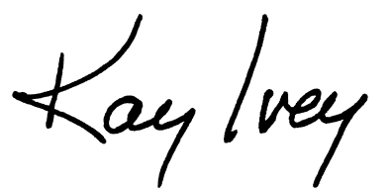

____________________________________
Kay Ivey, Governor

